Website User Manual

Our CRM system is designed for both our clients and our consultants. Our clients are only able to access to the **Registration Form** and they can fill the form at the reception desk. As a consultant, you can explore other functions after you login.

# Login

You can login to the system by using the username and password given to you. If you are a **new staff** and hasn’t been registered to the system or wish to **change the password**. Please feel free to contact the **Admin** or our IT staffs to add you into our consultants list.

# Interact with Client

With our CRM system, you can add clients and view the information of the clients who you are helping.

* **Add** client: Login/CLIENTS -> ADD CLIENT

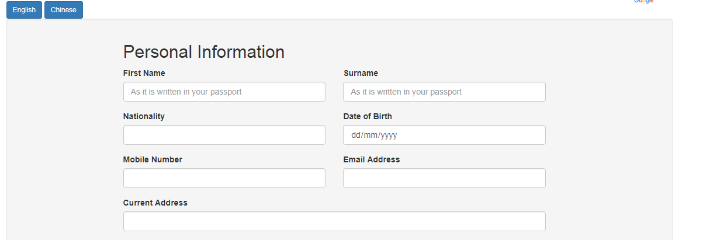

* **View** Clients’ information and Make **Modifications**: Login/CLIENTS -> Click the clients you willing to view/make changes -> Client Information

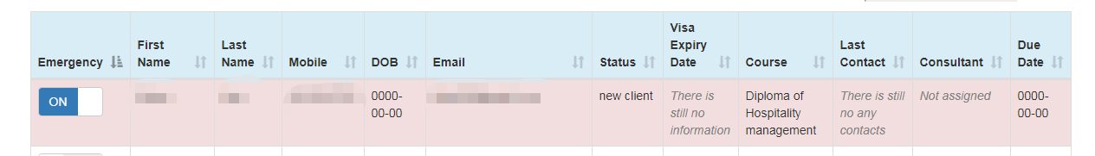

**Tips:**

* Clients who are in ‘**Emergency’** status will be highlight with colour, while others will not.
* As shown in the Figure below, you can **sort** the clients by clicking the arrow in corresponding columns

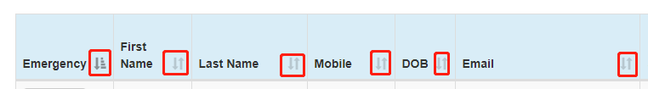

* **Search** Client: Login/CLIENTS -> Search by First Name/ Last Name/Date of Birth/Phone Number/Visa Expiry Date/Last Contact Date in/Status/Consultant Name (You can reset the search bar by clicking ‘Reset Search’)

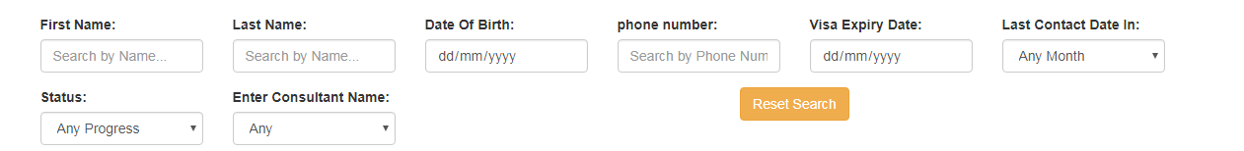

* **Print** Client List: Login/CLIENTS -> Print
* **Point Test**: Login/CLIENTS -> Click the client -> Point Test

# Logout

Do not forget to logout every time you leave. Logout button in on the right corner of each page.

